**Question – 1 Define a structure Employee with member variables id, name, salary.**

**Ans.**

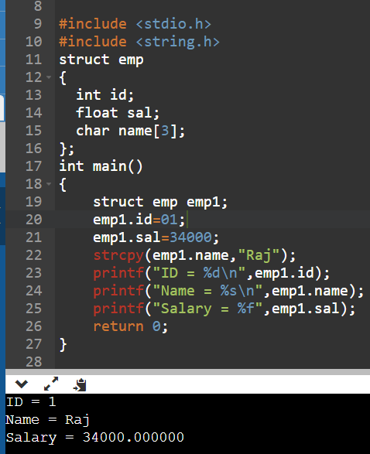

**Question – 2 Write a function to take input employee data from the user. [ Refer structure from question 1 ].**

**Ans.**

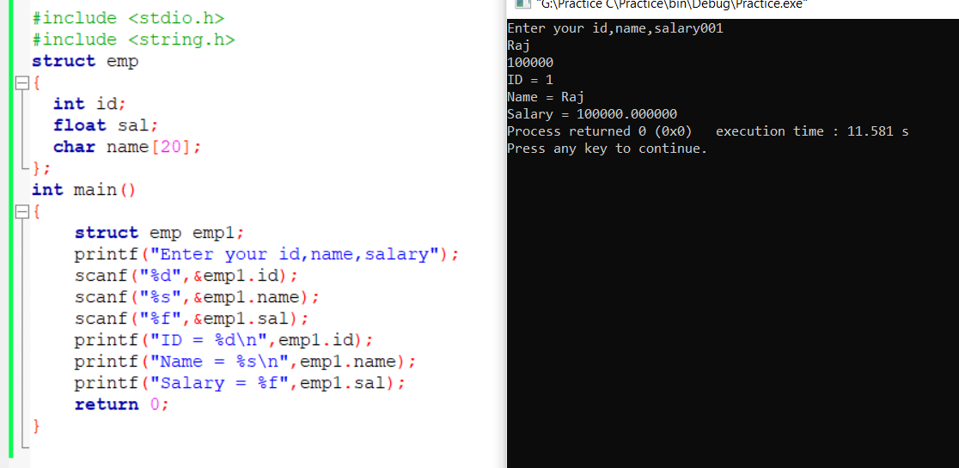

**Question – 3 Write a function to display employee data. [ Refer structure from question 1 ]**

**Ans.**

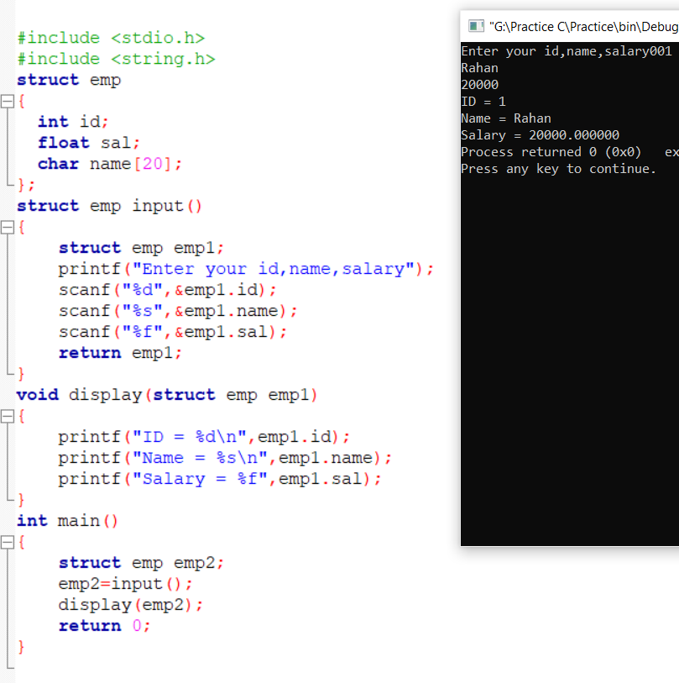

**Question – 4 Write a function to find the highest salary employee from a given array of 10 employees. [ Refer structure from question 1].**

**Ans.**

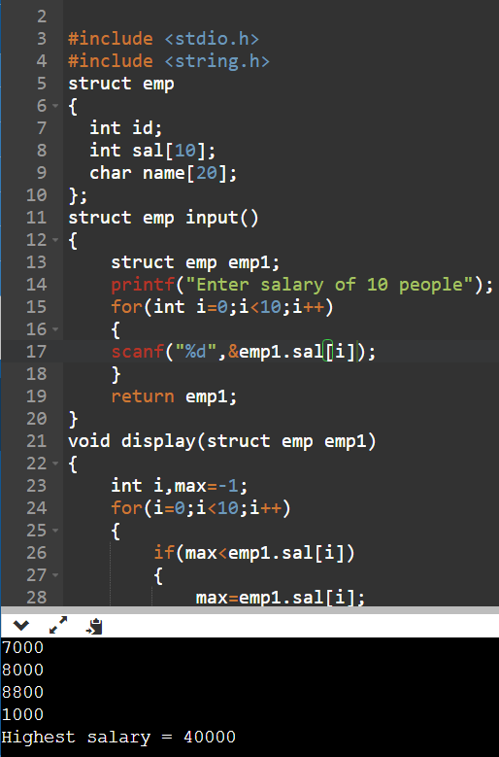

**Question – 5 Write a function to sort employees according to their salaries [ refer structure from**

**question 1].**

**Ans.**

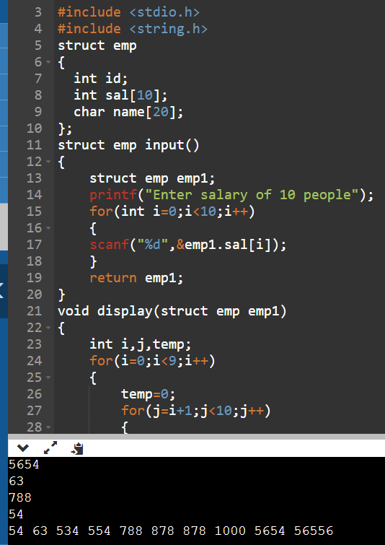

**Question – 7 Write a program to calculate the difference between two time periods.**

**Ans.**

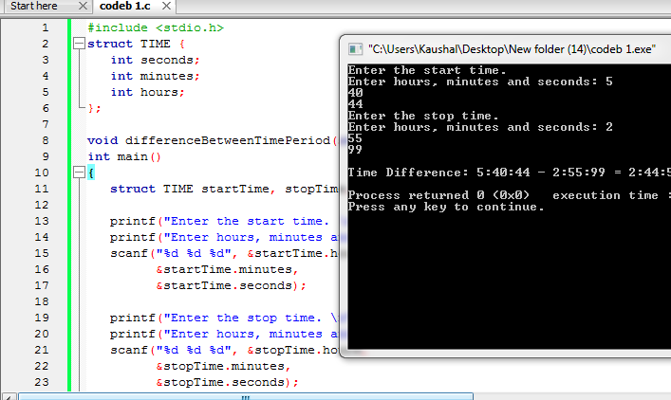

**Question – 8 Write a program to store information of 10 students and display them using structure.**

**Ans.**

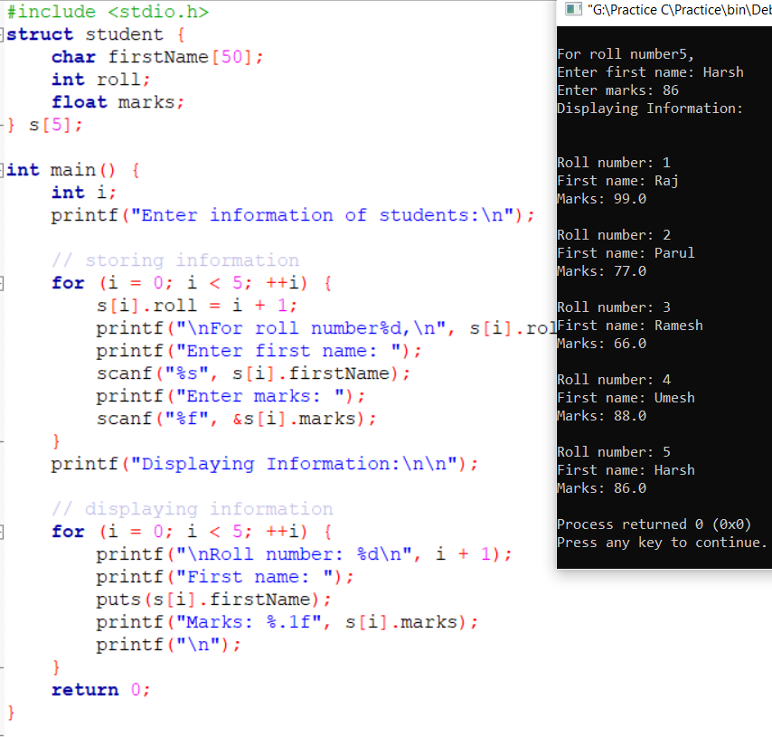

**Question – 9 Write a program to store information of n students and display them using structure.**

**Ans.**

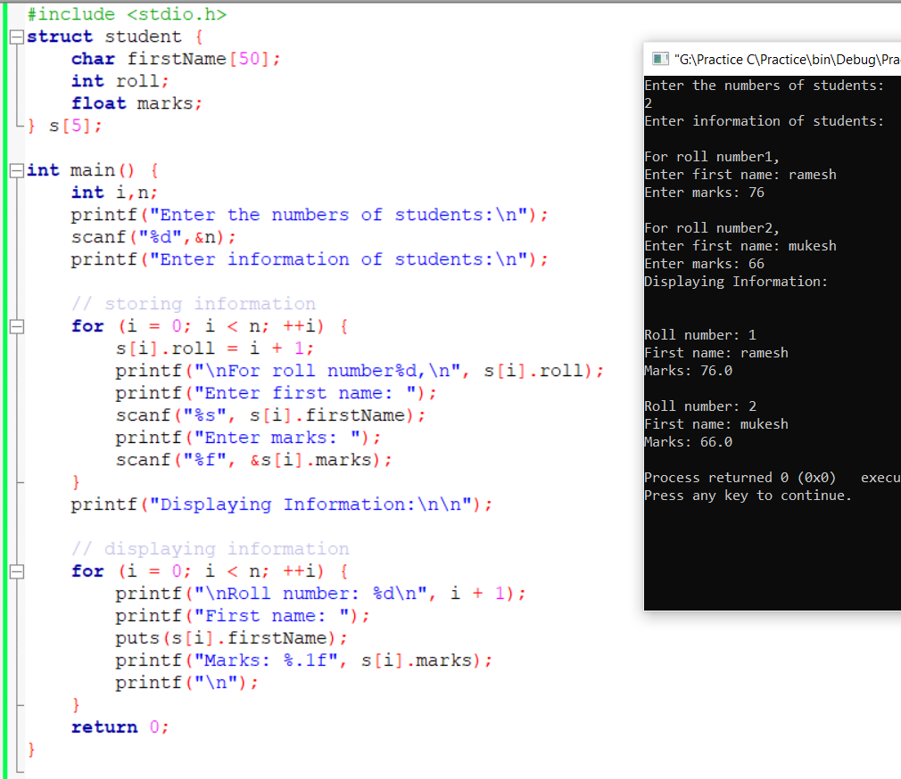

**Question – 10 Write a program to enter the marks of 5 students in Chemistry, Mathematics and Physics (each out of 100) using a structure named Marks having elements roll no., name, chem_marks, maths_marks and phy_marks and then display the percentage of each student.**

**Ans.**

